To all participants and supporters of WX4E ARRL Field Day 2026,

The Charlotte Amateur Radio Society, CARSFL.org, is hosting ARRL Field Day 2026. ARRL Field Day (FD) is an exciting annual event for amateur radio enthusiasts, taking place on the last full weekend of June. It offers a unique opportunity for radio operators to set up field operations in remote locations, enabling them to connect with participants worldwide.
This year’s event will be held on June 27th and 28th at the Peace River & Palm Shores Social Club property, located at 29075 Riverview Ln. Punta Gorda, FL, 33982.
This yearly event tests our emergency communications skills and demonstrates to Charlotte County residents and beyond, how amateur radio supports our community in the case of disaster.
We encourage any amateur radio operator, and those wishing to become licensed operators to attend the event and learn more about contesting and emergency communications. FD is a fun and learning event where not only amateur radio operators polish their skills, but where community leaders can see firsthand and closeup how multiple antennas are erected, how numerous radios operate on several different frequencies, and how operators communicate under demanding conditions.
One communication technique for ARRL Field Day is WinLink messaging. The system primarily serves radio users without normal access to the internet, government and non-government public service organizations, medical and humanitarian non-profits, and emergency communications organizations. WinLink plays a vital role in emergency communications for our community and communities throughout the country. The process involves digitizing a message and sending the message via radio transmission to another ham radio operator enabling written communication without the internet. Without WinLink many

would go without vital information during a disaster when internet services may not be available.
One goal of FD is to send WinLink messages to other operators and to receive a WinLink response from that operator. Your WinLink response will be greatly appreciated.
Best regards 73
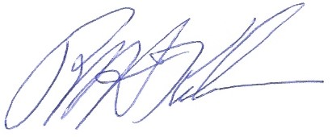
Richard “Rick” Kilmer
KQ4JXF
CARS Field Day Coordinator

